Assignment 9.1

NAME:- E.Srivarsha H.T.No:2303A52343 Problem 1:-
Consider the following Python function: (c) Google-style documentation def find_max(numbers): • Critically compare the three approaches. Discuss return max(numbers) the advantages, disadvantages, and suitable
Task: use cases of each style.
• Write documentation for the function in all three • Recommend which documentation style is most formats: effective for a mathematical utilities library and
- Docstring justify your answer.
- Inline comments

CODE:-
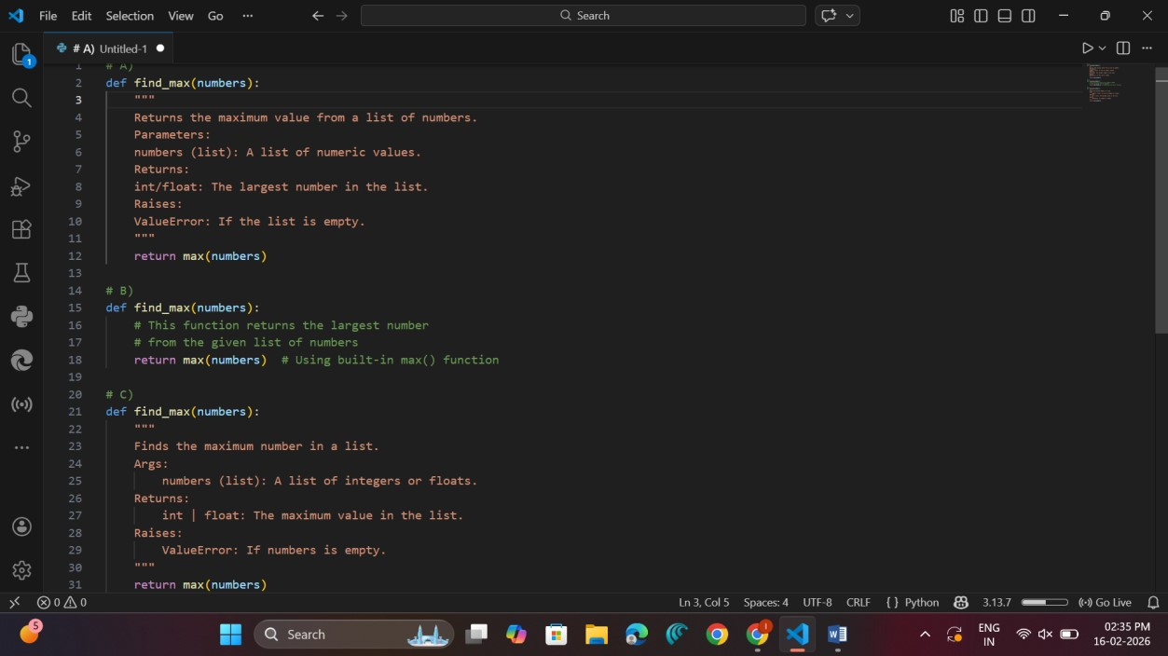

Style | Advantages | Disadvantages | Suitable Use Case
Docstring (Basic) | Simple and readable | Not standardized | Small projects
Inline  Comments | Easy to understand lineby-line | Cannot generate automatic documentation | Beginners / Learning
Google Style | Structured, professional, tool-compatible | Slightly longer | Large projects & libraries

• Recommend which documentation style is most effective for a mathematical utilities library and justify your answer.

Recommendation for Mathematical Utilities Library
Google-style documentation is most effective because: • Works well with tools like pydoc, Sphinx
- Clear parameter and return description
- Professional and standardized
Problem 2:
Consider the following Python function: 1. Write documentation in all three formats.
def login(user, password, credentials):
  - Critically compare the approaches.
return credentials.get(user) == password
  - Recommend which style would be most
Task: helpful for new developers onboarding a project, and justify your choice.
CODE:-
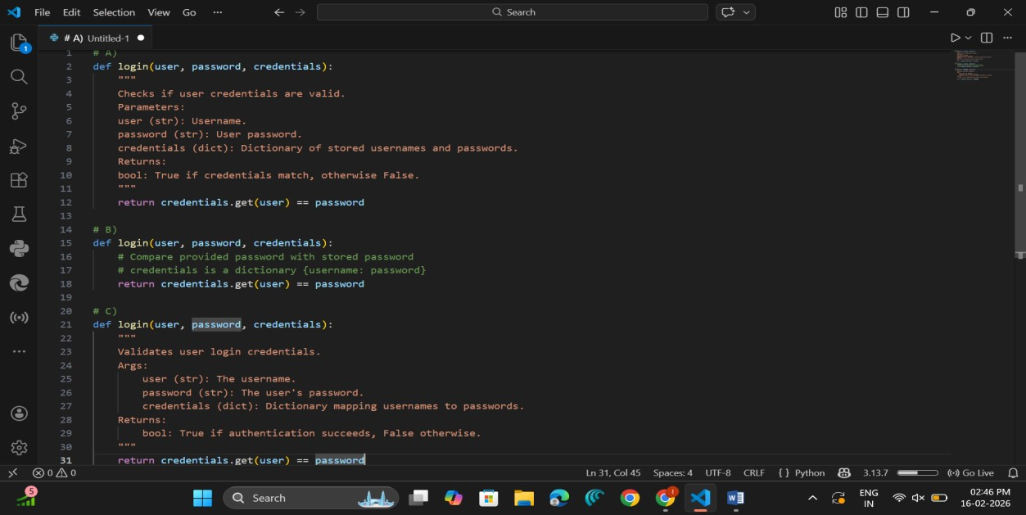

Critical Comparison
- Inline comments → Helpful for beginners
- Basic docstring → Simple but less structured • Google style → Best for onboarding developers because:
o Clear argument explanation o Explicit return type o Easily readable by documentation tools

Recommendation for New Developers
Google-style documentation is most helpful because:
- Clearly explains inputs & outputs
- Professional standard
- Helps new developers quickly understand the function
Problem 3:
Calculator (Automatic Documentation Generation) Task: Design a Python module named calculator.py and demonstrate automatic documentation generation.
Instructions:
1. Create a Python module calculator.py that includes the
following functions, each written with appropriate docstrings:
o add(a, b) – returns the sum of two numbers o subtract(a, b) – returns the difference of two numbers o multiply(a, b) – returns the product of two numbers o divide(a, b) – returns the quotient of two numbers 2. Display the module documentation in the terminal using Python’s documentation tools.
3. Generate and export the module documentation in HTML format using the pydoc utility, and open the generated HTML file in a web browser to verify the output.

CODE:-
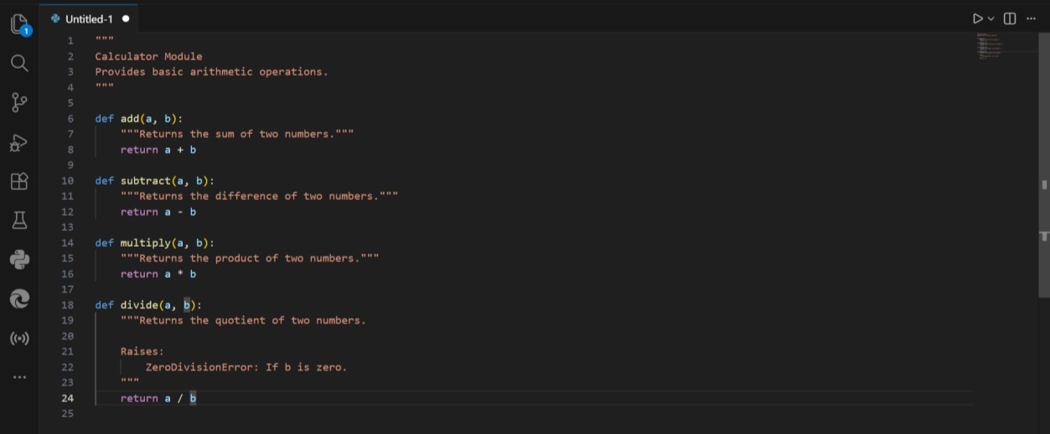

Observation
- The module calculator.py was successfully created with four arithmetic functions:
  - add(a, b) o subtract(a, b) o multiply(a, b) o divide(a, b)
- Each function contained proper docstrings, which:
  - Described the purpose of the function. o Specified parameters and return values.
  - Mentioned possible exceptions (e.g., ZeroDivisionError).
- When executing:
- python -m pydoc calculator
- The documentation was correctly displayed in the terminal.
- When executing:
- python -m pydoc -w calculator
An HTML file named calculator.html was generated successfully.
- Opening the HTML file in a browser displayed:
Problem 4:
Conversion Utilities Module
Task:
1. Write a module named conversion.py with 2. Use Copilot for auto-generating docstrings. functions:
3. Generate documentation in the terminal.
- decimal_to_binary(n)
4. Export the documentation in HTML format
- binary_to_decimal(b) and open it in a o decimal_to_hexadecimal(n) browser.

CODE:-
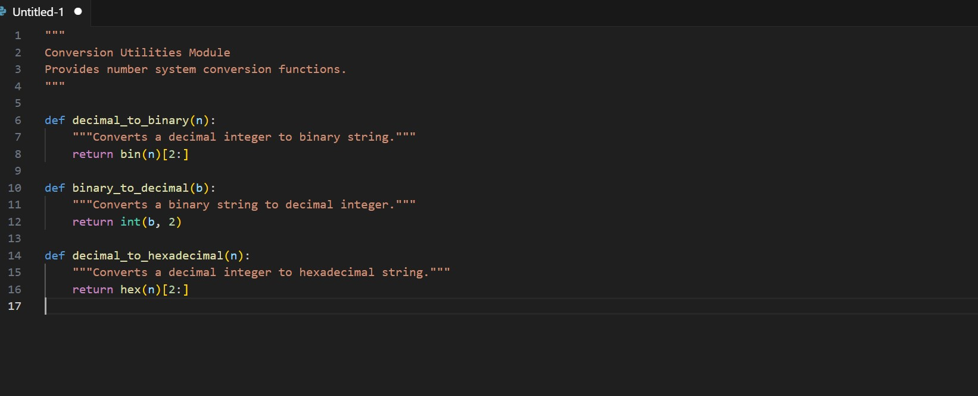

Observation
- The module conversion.py was created with functions:
  - decimal_to_binary(n) o binary_to_decimal(b) o decimal_to_hexadecimal(n)
- Docstrings were auto-generated (simulated using Copilot-style documentation).
- Terminal documentation generation: 4. python -m pydoc conversion displayed:
  - Function names o Function descriptions o Module summary
5. HTML documentation generation: 6. python -m pydoc -w conversion successfully created conversion.html.
7. The HTML file displayed well-formatted documentation in browser view.

Problem 5
Course Management Module Task:
1. Create a module course.py with functions:  o add_course(course_id, name, credits) o remove_course(course_id) | - Add docstrings with Copilot.  - Generate documentation in the terminal.  - Export the documentation in HTML format and open it in a browser
o get_course(course_id)

CODE:-
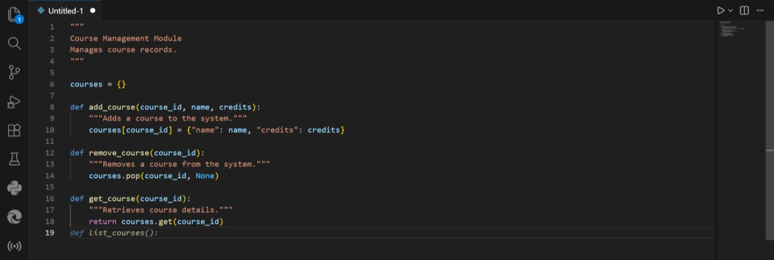

Observation
- The module course.py was created with functions:
  - add_course(course_id, name, credits) o remove_course(course_id) o get_course(course_id)
- Each function included meaningful docstrings explaining:
  - Purpose o Parameters o Return values
- Terminal documentation command: 4. python -m pydoc course correctly displayed module documentation.
5. HTML documentation command: 6. python -m pydoc -w course generated course.html successfully.
7. The generated HTML file clearly structured:
o Module information o Function details o Available methods

